15th Annual
Eastern Pennsylvania Longrifle Show, LLC
September 27th. & 28th.
WYNDAM GARDEN
2000 Loucks Road York, Pa. 17408
When making room reservations ask for EPLS rates
$99.00 (One King) / $119.00 (Two Queen) plus tax
Make your reservation before 9/10/2024) to get Show rate 717-846-9500
(make sure you are talking to hotel desk attendant not central reservation)
You must cancel 72 hours before date if unable to attend
SHOW HOURS
Fri. September 27th. 9:00 a.m. 5:00 p.m. (Table holders only 5:00 p.m. to ??)
Sat. September 28th. 9:00 a.m. to 2:00 p.m.
Admission $10.00
Vender setup Thursday 5:00 p.m. to 9:00 p.m.
Friday 7:30 a.m.
----------Security will be provided -------
The “Kentucky Rifle Foundation “will sponsor a display of Schreyer/Shroyer Rifles

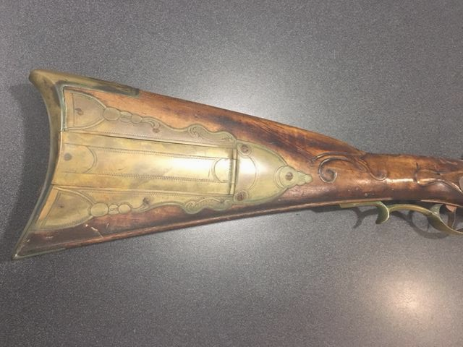

This is an Historical Arms Collector/ Contemporary Builders/ Suppliers & Artisan show with a goal of informing, educating and sharing knowledge with others. Kentucky Rifles & Pistols, Accouterments & all Antique arms acceptable. Buy, Sell, Trade!
ABSOLUTELY NO SMOKELESS POWDER CARTRIDGE GUNS OR AMMO
____________________________________________________________________________________________________________
You are responsible for providing your own insurance to cover any loss you may sustain. The sponsor assumes no liability for personal liability, loss or damage to person or property. Submission of the registration form acknowledges your acceptance of this wavier.

8ft. tables____ x $85.00 each = _______________
Name; _________________________________ 2nd. Badge; ____________________________
Address; ____________________________________________________________________
Phone no.; ___________________ email __________________________________________

Payable to “Eastern Pennsylvania Longrifle Show, LLC”
Send to: R. Mac Spencer
631 Church Hill Road
Landenberg, Pa. 19350
484-678-1314 (C)
royspencer@outlook.com – e-mail

